
SCHOOL OF COMPUTING AND ENGINEERING SCIENCES (SCES)
BACHELOR OF SCIENCE IN ELECTRICAL AND ELECTRONICS ENGINEERING (BSEEE)
DIGITAL ELECTRONICS LAB THREE.
COMBINATIONAL AND SEQUENTIAL CIRCUITS
GROUP 16
BY:
- Mwongela Edward Aribu 142092
COLLABORATORS:
- Nzioki, Andrew Christopher | 145168
- Karumbi, Ivy Waceke | 145338
- Onyango, Andrian Achieng | 146738

Table of Contents
LIST OF FIGURES 3
INTRODUCTION 4
METHODOLOGY 5
Objectives: 5
Learning Outcome 5
Equipment Needed 5
Pre-Lab Activities 5
Simulate the design of your 4 Bit adder in Proteus and present oscilloscope output waveforms to show that your 4 bit adder design produces the correct results when you carry the arithmetic operations shown in Fig. 4.1.2. 7
Replace the Proteus oscilloscope display and drive a set of 4 LEDs to indicate the result of the arithmetic operations and record status of the LEDs(on/off) for each addition/subtraction shown in Fig. 4.1.2. 8
4.2 Level Detector 9
Build the circuit in Proteus and simulate its operations. Answer the following questions: 9
REFERENCES 10

LIST OF FIGURES
Figure 1 4
Figure 2 5
Figure 3 8
Figure 4 9
Figure 5 10

INTRODUCTION

FULL ADDER IMPLEMENTATION
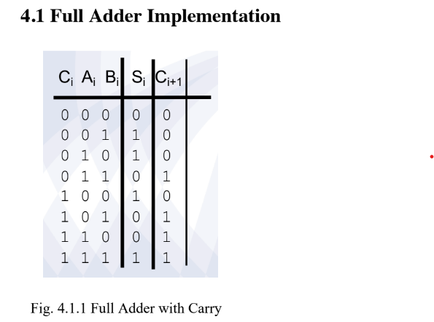
Figure 1

LEVEL DETECTOR
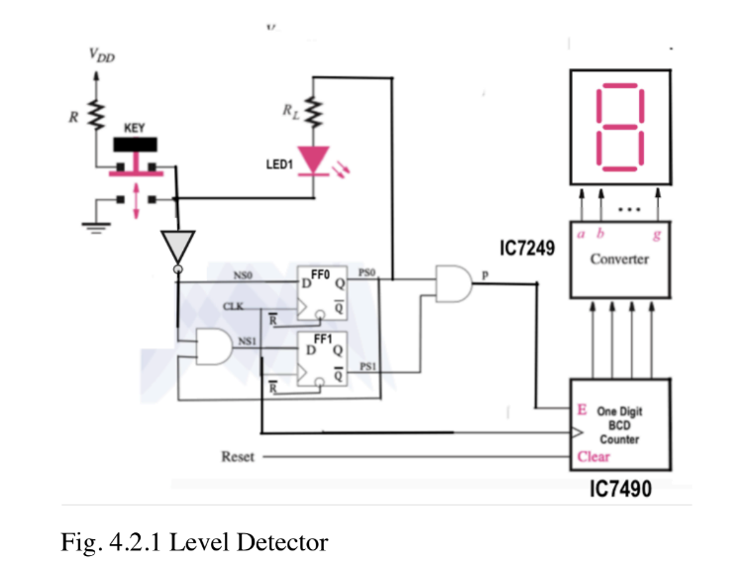
Figure 2

METHODOLOGY

Objectives:

i) Use basic gates to build and test a 4 bit Full Adder
ii) Use Flip Flops to build and test a level detector

Learning Outcome
Apply logic expressions simplification rules and K-maps to minimize logic expressions and use the minimized expressions to build digital devices.

Equipment Needed
- 2 Data Flip flop
- Arduino Uno kit
- Jumper wires
- 2 Resistors
- 5V supply
- 2 AND gates
- NOT gate
- 7447
- 74LS90

Pre-Lab Activities
Fig. 4.1.1 shows the truth table of a full adder with carry. Reduce and/or representations of the sum Si and carry Ci+1 into XORs

The 4-bit adder is used to carry out the addition and subtraction using 2s complement of 3-bit numbers with the fourth bit used as a sign bit. Design and draw a schematic of a circuit that uses a set of 4 input switches as binary input plus AND, and XOR logic to implement a 4 Bit adder.

Simulate the design of your 4 Bit adder in Proteus and present oscilloscope output waveforms to show that your 4-bit adder design produces the correct results when you carry the arithmetic operations shown in Fig. 4.1.2.
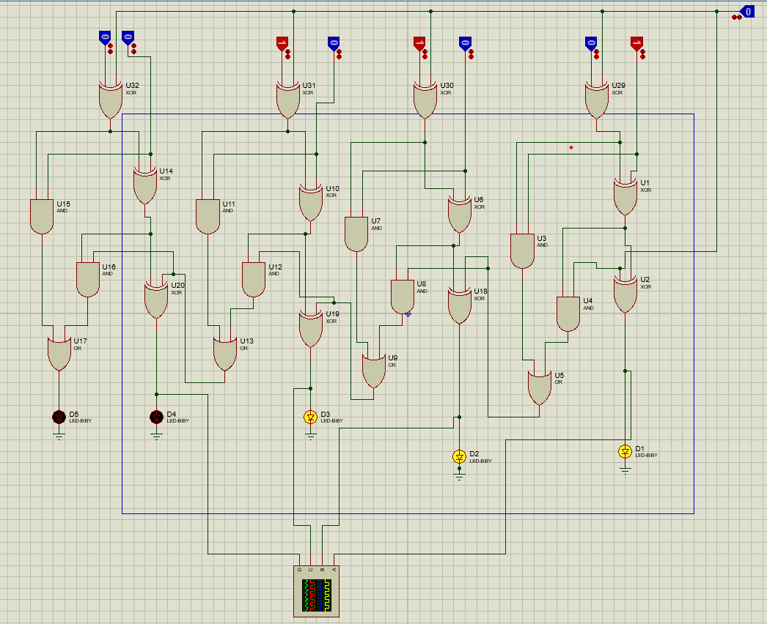
Figure 3

Replace the Proteus oscilloscope display and drive a set of 4 LEDs to indicate the result of the arithmetic operations and record status of the LEDs(on/off) for each addition/subtraction shown in Fig. 4.1.2.

Figure 4

4.2 Level Detector

Build the circuit in Proteus and simulate its operations. Answer the following questions:

(i) The LED1 is a measure of how long the Key is pressed. At a clock pulse of 1Hz, is the count faster or slower than the key press period as observed by how long LED1 is lit.
The count is slower as the flip flops do not have time to record the data as per the clock speed.

(ii) At an input clock of 1 Hz, if p is disconnected and input of FF0 directly connected to the enable E input of the counter what happens to the count when the Key is pressed? Increase the clock frequency and observe what happens to the count.
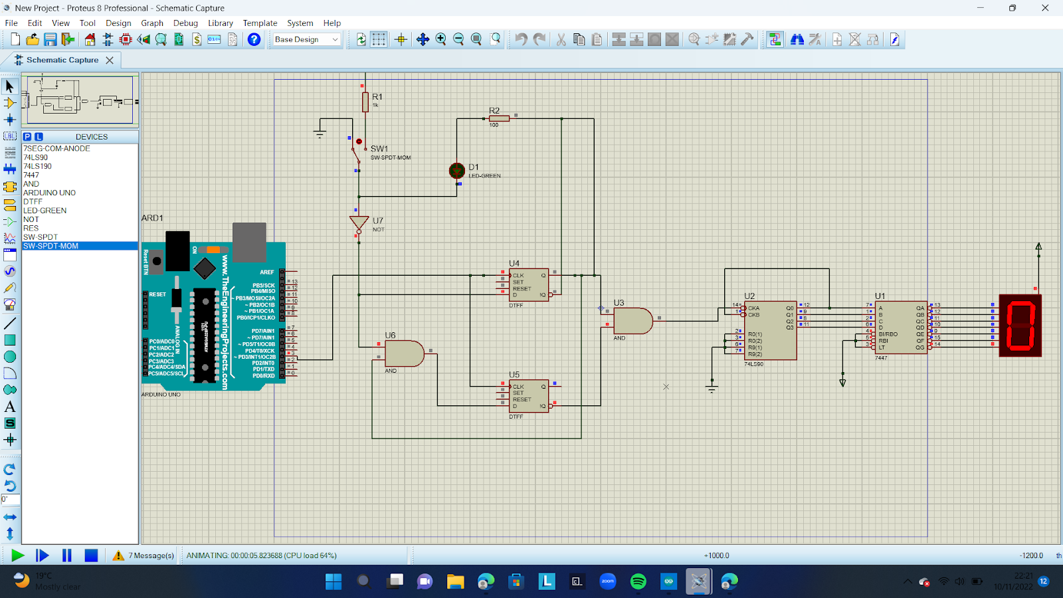
Figure 5
The count increases on its own without solicitation by the pressing of the keys; when the frequency of the clock is increased the speed of the count increases.
(iii) Measure the time the Key is pressed by connecting Q of FF0 to the enable E input of the counter.
2 seconds

Simulation circuit:

REFERENCES
https://drive.google.com/drive/u/0/folders/1cmlpB7eoggtf8CTZ7-qv7cPXfbII72fW

